Thornton Public School
Attendance Policy and Procedures
2021-2022

In conjunction with School Attendance Policy – PD20050259

Contents
Rationale

1:Benefits of regular attendance
(1.1) for students
(1.2) for teachers
(1.3) for parents/caregivers
(1.4) for the community

2:Responsibilities
(2.1) student responsibilities
(2.2) parent responsibilities
(2.3) teacher responsibilities
(2.4) school attendance coordinator responsibilities
(2.5) administrative staff responsibilities
(2.6) Principal responsibilities

3:Promoting good attendance
(3.1) with parents
(3.2) with students
(3.3) with staff

4:Attendance targets

5:Appendix

All of the following documents can be accessed via the staff ‘Google Attendance’ drive, within the

Appendix 1 School Attendance Flow Chart
Appendix 2 Attendance Intervention Checklist
Appendix 3 Phone Intervention Program (PIPs)
Appendix 4 Attendance Matters
Appendix 5 Attendance Information Letter for Parents/Carer
Appendix 6 Attendance Concern Letter- Phase 1 and 2
Appendix 7 DoE Attendance Parent Resource

Rationale

All schools in New South Wales are committed to providing safe and supportive learning environments for all students which address their educational needs. In NSW all children between the ages of six and below the minimum school leaving age of seventeen are legally required to attend school or an educational facility. Regular attendance at school is essential if students are to maximise their academic and social potential. Schools, in partnership with parents, are responsible for promoting the regular attendance of schools. Parents are legally responsible for the regular attendance of their children and school staff are responsible for the monitoring of part or whole day absences.

The Thornton Public School Attendance Procedures document aims to provide teachers, parents and community members with an understanding of the school processes to ensure that every student has the opportunity to attend school regularly.

- Benefits of Regular Attendance
Regular attendance has benefits for students, teachers, parents/caregivers and the community

These benefits include:

(1.1) For students
- (1.1.1) maximising learning opportunities which will optimise life choices
- (1.1.2) assisting to develop skills and attitudes that will help the student be successful later in life, such as; punctuality, organisation and confidence
- (1.1.3) success in learning outcomes
- (1.1.4) making friends and learning to maintain relationships
- (1.1.5) learning social skills to interact with others.

(1.2) For teachers

- (1.2.1) improved learning outcomes for all
- (1.2.2) ability to fulfil responsibilities to all students
- (1.2.3) maintaining relationships with students, which may reduce disruptions to learning due to poor student behaviour
- (1.2.4) saving resources and time by avoiding non-attendance follow up procedures.

(1.3) For parents/caregivers

- (1.3.1) children are safer at school than being unsupervised at home or in the community
- (1.3.2) children can succeed in their learning
- (1.3.3) children are more likely to complete Year 12 and have broader opportunities and higher educational goals
- (1.3.4) fewer incidents of negative contact with government agencies.

(1.4) For the community
- (1.4.1) increased level of safety for all
- (1.4.2) young people are less likely to be involved in criminal behaviour
- (1.4.3) the community as a whole will experience less cost, both financially and socially.

Responsibilities

Regular attendance at school is the responsibility of students, parents and school staff.
(2.1) Student responsibilities:
- (2.1.1) arrive punctually between 8:30 and 9:00 am
- (2.1.2) attend school every day between 9:00am and 3:00pm
- (2.1.3) attend school every day when instruction is offered unless the school receives a valid reason for being absent (e.g. sickness)
- (2.1.4) hand letters or notes from parents to the front office or classroom teacher promptly
- (2.1.5) when arriving late, students are required to present at the office, before going to class with a late slip
- (2.1.6) if late, come to class quietly so as not to disturb other students’ learning.

(2.2) Parent responsibilities:

- (2.2.1) actively encourage their children to regularly attend school
- (2.2.2) notify the school of any absences in verbal, written or electronic form within 7 days
- (2.2.3) provide the office with an appropriate, justifiable explanation for arriving late or leaving early
- (2.2.4) inform the school if an extended absence is likely or if they would like the school to arrange work at home for the student
- (2.2.5) inform the school when their child is away for more than 2 consecutive days
- (2.2.6) inform the school of any changes to their contact details
- (2.2.7) ensure children are picked up promptly from school at the end of the school day at 3:00pm
- (2.2.8) contact the school if delayed for any reason or length of time when picking up children

(2.3) Teacher responsibilities:

- (2.3.1) actively encourage students to attend school regularly by providing an engaging, educational program which is inclusive of the needs of all learners
- (2.3.2) monitor each child’s attendance and implement the school’s attendance procedures by following the Attendance Procedures Flow-Chart
- (2.3.3) implement strategies aimed at increasing school attendance, as outlined in the Attendance Procedures Flow-Chart
- (2.3.4) accurately completes the attendance register (roll) on Sentral each day. If internet access is down, teachers must complete a paper roll and send it to the office
- (2.3.5) complete a paper roll for the class when attending approved school activities, such as excursions and sporting events. Provide a copy of this roll to administrative staff
- (2.3.6) use Sentral to complete ‘school business’ absences when students are attending offsite school based activities
- (2.3.7) remind students of the need to supply a note when returning to school, if absence is not yet explained
- (2.3.8) coordinate the collection of work for students who are unable to attend school for acceptable reasons, when requested by parents/carers
- (2.3.9) inform the School Attendance Coordinator of any concerns about attendance, including a completed intervention checklist, as outlined in the Attendance Procedures Flow-Chart
- (2.3.10) complete student interview when there is a concern and inform Attendance Coordinator
- (2.3.11) it is the teacher’s responsibility to investigate and follow through absences during this early stage.

(2.4) School Attendance Coordinator responsibilities:

- (2.4.1) analyse Sentral attendance data and identify students with an attendance concern.
- (2.4.2) take action when attendance concerns are raised by class teachers, as detailed in the Attendance Procedures Flow-Chart
- (2.4.3) complete warning letters to parents, notifying them that attendance is a concern
- (2.4.4) submit Home School Liaison Applications when all strategies have been implemented, as outlined in the Attendance Procedures Flow-Chart
- (2.4.5) lead whole school attendance initiative such as whole class attendance trophy, 100% attendance certificates
- (2.4.6) attend Learning Support Team Meetings to discuss any student who is displaying a concerning pattern of attendance
- (2.4.7) present and/or provide information packs for Kindergarten orientation and stage parent/teacher meetings
- (2.4.8) provide the administrative staff with regular newsletter items to include in the school newsletter
- (2.4.9) support classroom teachers with resources and ideas to promote attendance within the classroom and around the school
- (2.4.10) introduce TPS Attendance Policy and Procedures with new staff and casual teachers
- (2.4.11) provide professional development sessions for all school staff in roll marking procedures, school and Department attendance policies and procedures
- (2.4.12) liaise with administrative staff to ensure the efficiency of roll collection, late arrival sign on and early departure sign out procedures
- (2.4.13) document interventions, strategies and parent contact/meetings in Sentral Welfare section
- (2.4.14) if the student with attendance concerns is Aboriginal, seek the advice and assistance of the School Aboriginal Education Officer.

(2.5) Administrative Staff Responsibilities:

- (2.5.1) input absence notes onto Sentral
- (2.5.2) input late arrival and early leaver information onto Sentral, and provide students with a late arrival note
- (2.5.3) complete a Late Arrival Interview with students and/or their families
- (2.5.4) input late arrival information onto Sentral
- (2.5.5) contact parents following 2 consecutive days of unexplained absence. Follow the procedures for the Phone Interview Program (PIPs)
- (2.5.6) inform class teachers of relevant information about student absences provided by families
- (2.5.7) input attendance information provided by teachers when paper rolls are completed
- (2.5.8) make attendance data available to Home School Liaison Officer staff when requested
- (2.5.9) call the families of students with 2 consecutive days unexplained absence, using the PIPs procedures. If an acceptable reason is provided, adjust the information on Sentral.

(2.6) Principal & Deputy Principal Responsibilities:

- (2.6.1) ensure the attendance register is accurately completed by staff
- (2.6.2) when the classroom teacher or School Attendance Coordinator faces an unsatisfactory outcome, to be responsible for recommending future action
- (2.6.3) complete Child Wellbeing Unit report for Habitual Absence (Mandatory Reporting Guide) to accompany Home School Liaison referrals
- (2.6.4) contact the Child Wellbeing Unit or the Police when a student is absent for more than 2 consecutive days and the carers cannot be contacted

Promoting Good Attendance

At Thornton Public School we promote the importance of regular attendance to parents, students and staff through a range of strategies.
(3.1) Promoting good attendance with parents:

- (3.1.1) attendance coordinator/HSLO/teacher presents at the kindergarten orientation and provides information for stage and parent/teacher information sessions
- (3.1.2) class teachers promote the importance of regular attendance during Individualised Education Plan meetings
- (3.1.3) student reports inform parents of their child’s attendance each Semester
- (3.1.4) the school newsletter regularly provides an attendance focus for parents
- (3.1.5) school attendance pamphlet outlining the importance of regular attendance, the difference between justified and unjustified reasons of absence, partial absences and how to contact the school
- (3.1.6) attendance information letters are sent home each term notifying parents/carers of their child’s attendance percentage and tier

(3.2) Promoting good attendance with students:

- (3.2.1) all staff implement intervention strategies when students are identified with an attendance concern
- (3.2.2) when marking the roll, teachers discuss the importance of regular attendance
- (3.2.3) teachers encourage attendance through daily or weekly classroom competitions/incentives
- (3.2.4) students with improved attendance are acknowledged by the attendance coordinator and/or Deputy Principal
- (3.2.5) students with 100% and outstanding attendance are acknowledged each term with a certificate.
- (3.2.6) Classes with the highest attendance percentage are awarded with a class attendance trophy each fortnight and presented at assembly.

(3.3) Promoting good attendance with staff:

- (3.3.1) all staff engage in professional development to review roll marking procedures, the benefits of regular attendance and ways to improve and promote attendance
- (3.3.2) School Attendance Coordinator meets regularly with admin staff to discuss attendance issues
- (3.3.3) School Attendance Coordinator keeps staff updated about attendance initiatives and concerns at weekly staff meetings
- (3.3.4) class teachers are provided with the School Attendance Procedures.

Attendance Targets

At Thornton Public School we are committed to achieving the following targets in improving attendance:

- (4.1) decrease the amount of students arriving late and leaving early
- (4.2) decrease any disparity of absenteeism between Aboriginal and non-Aboriginal students by increasing Aboriginal student attendance rates
- (4.3) increase the Attendance rate across the school to all students greater than 95 % attendance
- (4.4) increase the number of students in red tier (below 85%), orange tier(85-90%), yellow tier (91-95%) to reach the target of over 95% attendance.

Thornton Public School
Attendance Process

PHASE 1 -Teacher Managed: Teacher makes phone contact with parent/carer following 3 consecutive days of unexplained absence. Teacher makes record on Sentral.

Initial Contact: Office staff to send text message making contact with parent/carer on each day of absence. Explanation recorded on Sentral and roll adjusted accordingly. Notify classroom teacher/Attendance coordinator if contact is unable to be made.

Classroom Teacher monitors whole day and partial attendance of students in their class

PHASE 3- Engaging Assistance: Stage Assistant Principal to liase with Attendance Coordinator if there has been no improvement to attendance. Attendance Coordinator to liaise with HSLO—Follow up:
1) Phone call home
2) School Attendance Meeting

If attendance improves, continue to monitor and follow process. Change in Sentral to Non Attendance Concern (green).
PHASE 4: Escalation Attendance Concern:
No improvement:
1. Application for HSLO support
2. School continue to support
Develop Attendance Improvement Plan (AIP) for parents and students to follow – review after 4 weeks. HSLO takes further actions.

PHASE 2-Executive Managed: If an unsatisfactory or no reason is provided—teacher discusses with their supervisor/Attendance Coordinator. Staff to check overall attendance on Sentral and determine if student is an attendance concern.

Student Attendance Checklist

Name: | Class: | Teacher: | Parent:

Record of Attendance
Term 1 |  | Term 2 |  | Term 3 |  | Term 4
Justified |  | Justified |  | Justified |  | Justified
Unjustified |  | Unjustified |  | Unjustified |  | Unjustified
Partial |  | Partial |  | Partial |  | Partial

Action Taken by school to restore attendance

Phase 1: Informing the Parent of Concern
Tick | Date
 |  | Teacher discussion with parent/carer regarding attendance
 |  | Phone call made to parent/caregiver expressing concern about attendance
Outcomes/Comments: Recorded on Sentral

Phase 2: Monitoring Attendance
Tick | Date
 |  | Class notifies Attendance Coordinator/AP
 |  | Attendance Coordinator contacts parent/carer
 |  | Attendance Concern Letter-Phase 1 sent to parent/carer
Outcomes/Comments: Recorded on Sentral

Phase 3: Engaging Assistance
Tick | Date
 |  | Attendance Coordinator to meet with HSLO to discuss attendance concerns
 |  | Request meeting with parent (School Attendance Meeting)
 |  | Attendance Concern Letter- Phase 2 send home to inform parent/carer attendance concern- no improvement
 |  | Request medical certificate if the student is sick for a number of days
 |  | Principal/Nominee to make contact with any outside agency
 |  | Continue incentive program and improvement award if appropriate
 |  | HSLO contacts external support
Outcomes/Comments: Recorded on Sentral

Phase 4: Escalation Attendance Concern

Tick | Date
 |  | Principal to complete HSLO Application
 |  | Placed on HSLO program
 |  | Contact parent/carers HSLO application has been made
 |  | Develop Attendance Improvement Plan (AIP) for parents and students to follow
 |  | Attendance now improved. No further action required at this stage
 |  | These actions have failed to improve attendance, referral to HSLO/ASLO program.
Outcomes/Comments: Recorded on Sentral

TPS Phone Intervention Program (PIPs) Protocols and Procedures Rationale
It is a requirement of the NSW Department of Education and Training that parents and carers be contacted after a child is absent for 2 consecutive school days. The PIPs program is designed to help schools meet this requirement and build positive relationships with parents and carers regarding student absences.
Maintaining student welfare is a vital part of the Phone Intervention Program. After two consecutive absences with no communication from parents or carers, a child’s welfare may be compromised. Under duty of care, staff must ascertain the child’s whereabouts.

The teacher is required to make initial telephone contact with parents or carers. PIPs contact involves:

- Informing parents that their child is absent from school
- Recording reasons given by the parent/carer for the absence on Sentral
- Using Sentral to update attendance data. Staff must include a note that this
attendance issues was resolved via the PIPs program
- Using Sentral (Wellbeing – Attendance) to note when contact with parents/carers has
not been possible
- Informing stage Assistant Principals/Attendance Coordinator when contact with
parents/carers has not been possible.

Class Teacher

- Call families of students on the PIPs program
- If main contact is uncontactable use 2nd contact or emergency contact
- Update Sentral attendance data when parents are contacted
- Informing stage Assistant Principals/Attendance Coordinator when contact with parents
Cares has not been possible.

Attendance Coordinator

- Monitor children with unexplained absences
- Liaise with Home School Liaison Officer (HSLO) about students with a high number of
unexplained absences
- Refer students to HSLO

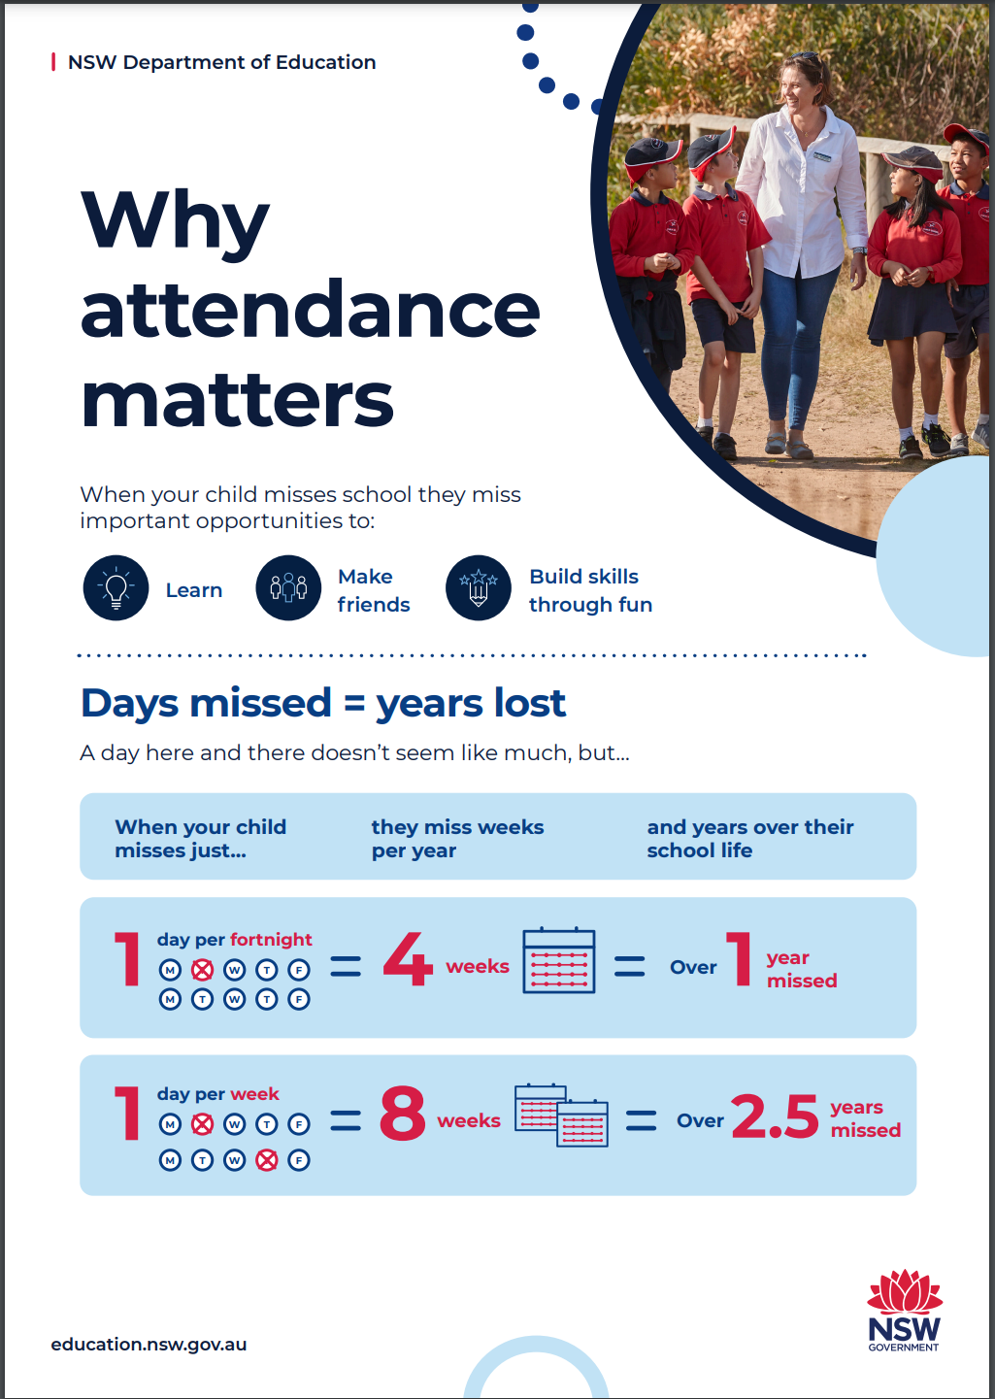

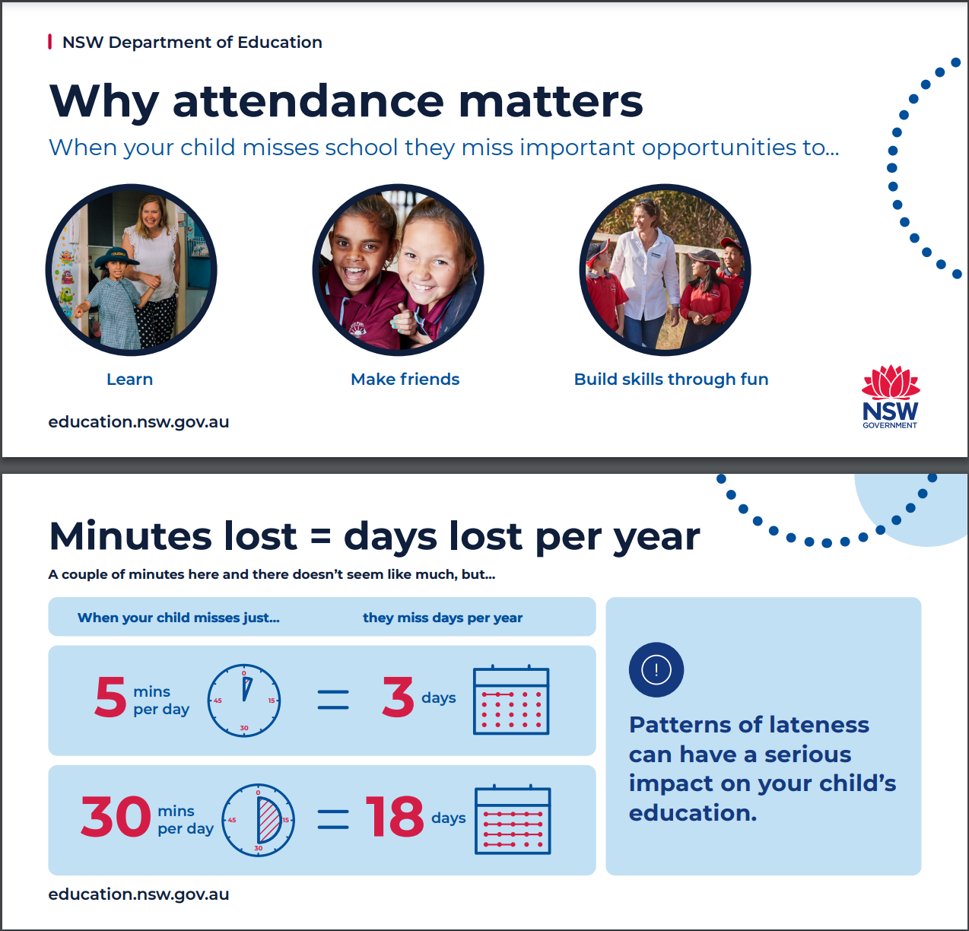

Attendance Information Letter

27 May 2021
Dear parent/caregiver of ,

Regular attendance at school is important for students to reach their full potential. The school is required to record the reason for any absences as a way of ensuring that students are absent from school only when they are sick or have another good reason for missing school.

Thornton Public School is implementing a new attendance strategy aimed at increasing the attendance of all students at school. Student attendance is monitored by teaching and executive staff. The attendance strategy will identify the current percentage of attendance for your child aligned with a coloured tier. The coloured tiers of the attendance strategy at Thornton Public School are:

GREEN Tier= 96-100% attendance
YELLOW Tier= 91-95% attendance
ORANGE Tier= 85-90% attendance
RED Tier= Below 85% attendance

Thornton Public School’s overall attendance target is over 95%.

As part of the new attendance strategy, the school will be celebrating attendance fortnightly with a class award at assemblies. We will also be rewarding a student in each class with the greatest growth percentage. Additionally, students with over 95% attendance will go into a draw to receive a prize each fortnight. All students with over 90% attendance at the end of each term will receive a small reward. To kick off this strategy the school wanted to communicate ’s attendance and the tier they are in at Thornton PS. Your child, ’s current attendance rate is %.

Your child, has a total of late arrivals and a total of early departures from school. Students who are late to school or leaving early are missing valuable instruction and consequently can have difﬁculty consolidating new concepts. It is important that good morning routines are established to ensure students are on time. As little as ten minutes every day can add up over the period of a year.

School staff remain committed to working in partnership with you to address the issues which are preventing from full participation at school.

If you want to know more about the attendance strategy, you may wish to contact the school on 4964 1369 to discuss your child's attendance or you can email thornton-p.school@det.nsw.edu.au

Yours sincerely,

Stuart Wylie
Principal

Attendance Concern Letter- Phase 1
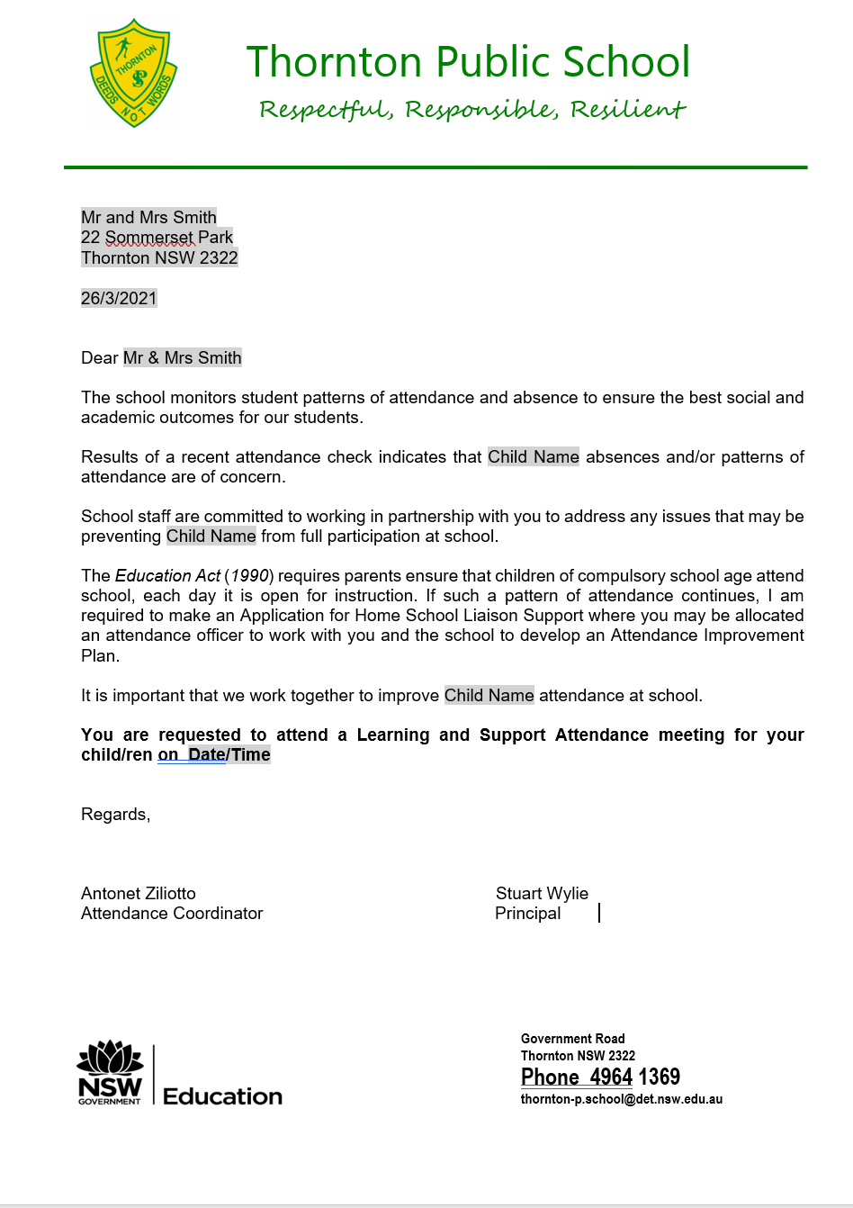

Attendance Concern Letter- Phase 2
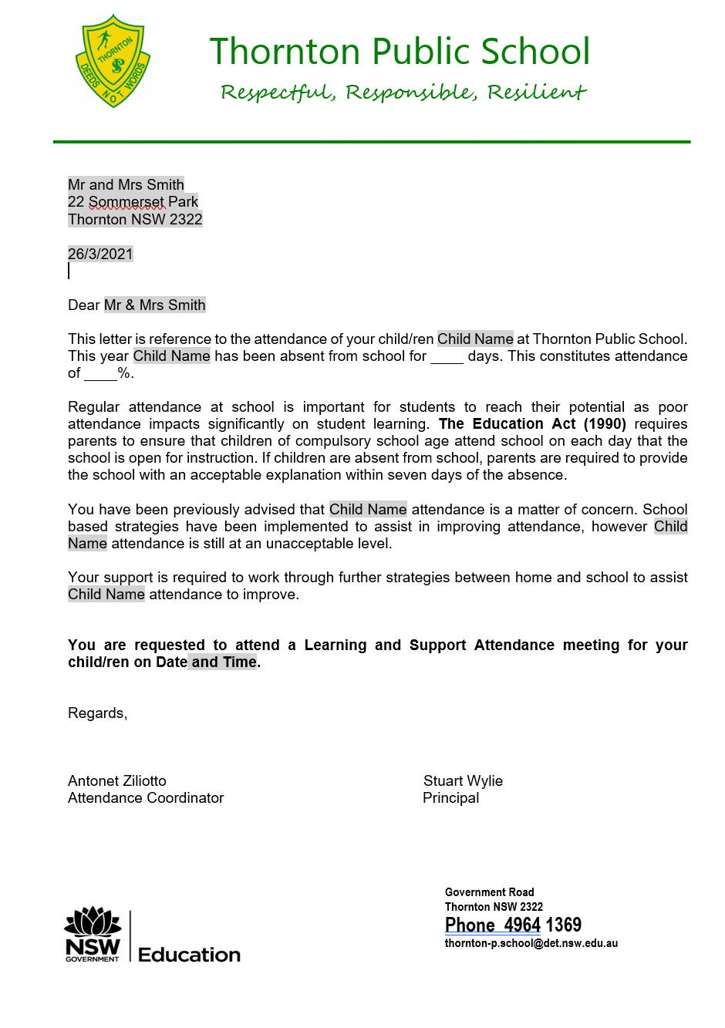
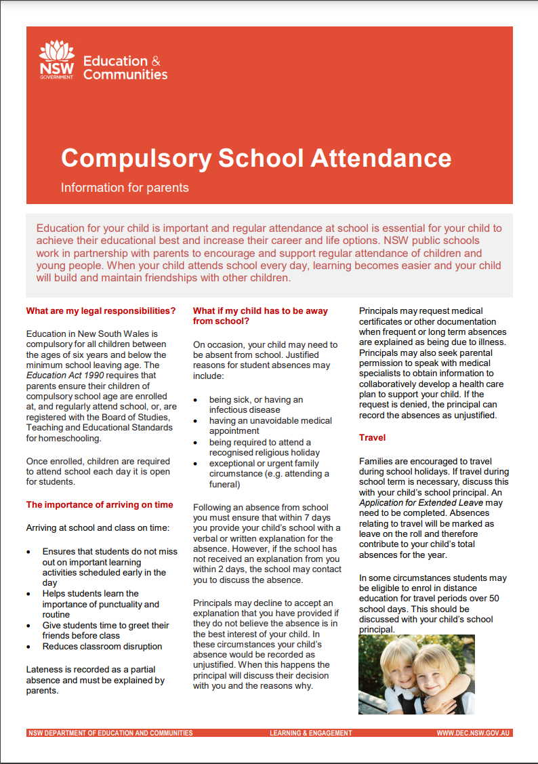
Parent Information

