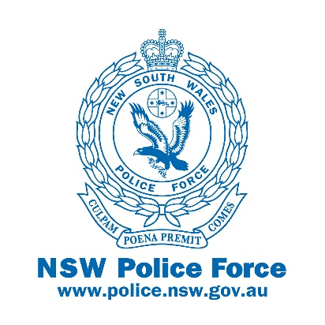
Port Stephens Hunter Police District
57 William Street,
RAYMOND TERRACE NSW 2324
Telephone 02 49830599 Facsimile: 02 4830511 ENet61599 EFax 61511xxxxx TTY 9211 3776 (Hearing/Speech impaired)
ABN 43 408 613 180

Dear Parents/caregivers

Many of you have made the decision to keep your child at home and continue schooling via alternative avenues due to the COVID-19 pandemic.

Port Stephens Hunter Police District is committed to assisting our schools in providing a safe, secure and caring learning environment for all students in this current climate.

Many of our children at some point in the upcoming weeks will be immersed in digital technologies to assist with their learning and to socialise with their friends.

Below are some quick tips for parents/caregivers to assist with some of the many issues and risks associated with using the internet.

- Chat with your child about online safety issues to help them make good choices.
- Set some boundaries around when and where they can use their devices.
- Use parental controls and safe search options.
- Look out for unwanted contact and grooming.
- Be aware of the signs of cyberbullying.

For further information websites such as safety.gov.au, thinkuknow.org.au offer current advice and resources.

Kind Regards

Leanne MANN & Rob WYLIE
Senior Constables
Youth Liaison Officers
Port Stephens Hunter Police District

