Early Stage 1
Learning at Home
Reading
As you currently do, please read with your child every day and encourage them to read to themselves.

Sounds
Each day choose a different letter/sound. Practise writing the letter and then draw 5 things that start with that sound.

Word Work
Choose at least one activity to do each day.
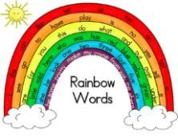  Choose 5 sight words and write them in rainbow colours. | Spell your words out loud while bouncing a ball or jumping on the trampoline.  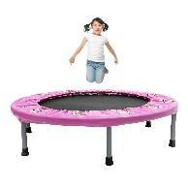 | Choose 10 sight word cards to play SNAP (You may need to write a second set of words). | Put 10 sight words around the back yard. Have someone call out the words and run and tag the word.  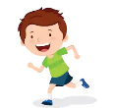 | Write your words with a paintbrush and water.  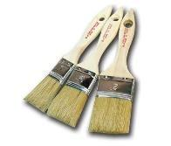
Choose 10 sight word  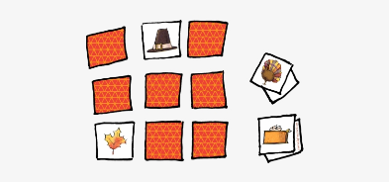  cards to play memory (You may need to write a second set of words). | With a scrap piece of paper make a paper chain and write your words on it.  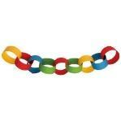 | Use newspapers or magazines to cut out letters to make your words. | Practise writing your name.  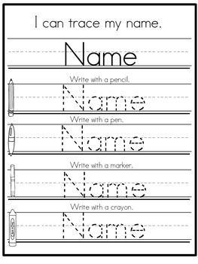 | Challenge yourself to write a sentence using a sight word.  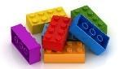

Maths
Use the cards provided or dice and choose some games to play from this list:
Play snap with your number cards (You may need to write a second set of number cards). | Practise writing numbers from 1 to 20.  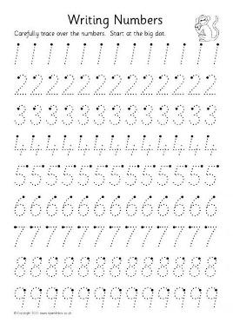 | Play MEMORY with your number cards (You may need to write a second set of number cards).  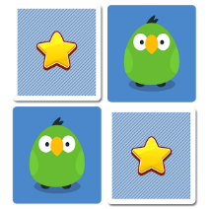 | 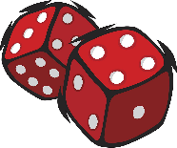  Roll two dice and add them together. | Flip 1 card. Use counters, marbles, pencils etc to represent the number.  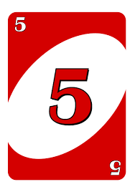
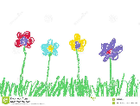  Pick one card, draw that number of things. | Pick two cards and add those numbers together. | Watch an episode of Numberjacks or Number blocks on Youtube  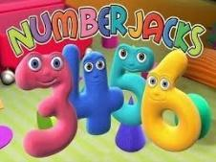 | Play GO FISH with your number cards (You may need to write a second set of number cards).  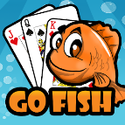 | Pick two cards and tell your family – the total of my cards is “__”. The family member needs to work out what your cards are. Show them 1 card if they get stuck.
Build towers from blocks. Ask your little learner to build with 8 blocks and then ask them to build a tower with 8 blocks that is different to the first. | Put your number cards in order as fast as you can. Have a race with someone in your family-counting forwards and backwards.  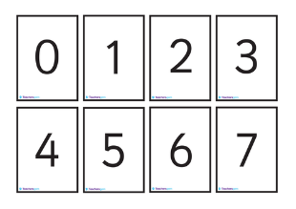 | Make a pattern with different shapes.  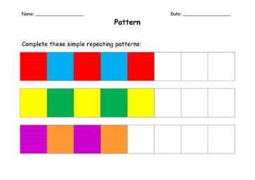 | Make a list of all the short and long objects in your house.  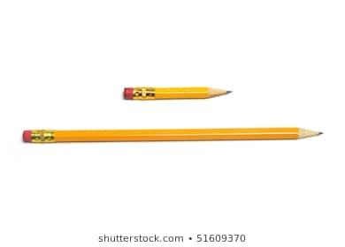 | Sing counting songs.  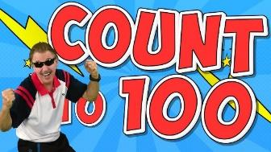

Free Choice
Choose at least one activity to do each day.
Play a board game with someone at home.  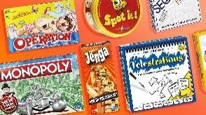 | Take the dog for a walk. | Help out in the kitchen, wash up, vacuum the floors.  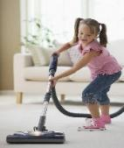 | Make an indoor / outdoor cubby house.  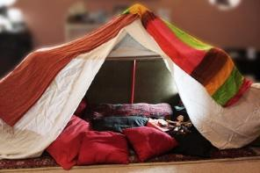 | Plan a picnic in your backyard with your family. Think about what you need to pack- food, drink, games etc.  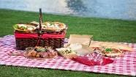
Find some recyclable materials and make them into something new.  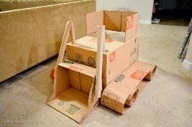 | Graph the weather each day – did it rain? – was it cloudy?  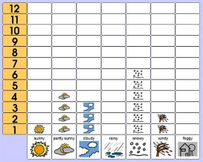 | Walk around your house and backyard looking for natural and built features. Record your findings by drawing pictures of what you find.  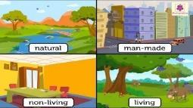 | Count aloud forwards to 20 or 30 and backwards from 20 whilst skipping with a skipping rope (one jump for each number). You could also do this jumping on the trampoline or bouncing a ball. Try challenging yourself to count by 2s, 5s and 10s.  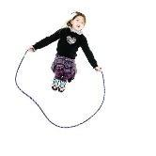 | Draw a floor plan of your house and label it – you can also include some comments about each room if you like.  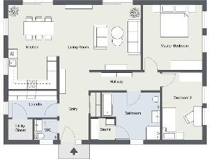
Create a 3D artwork of a chosen bug or insect.  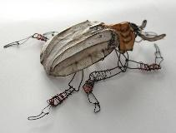 | Call a family member on the phone and talk about your day. | Make up a dance to your favourite song. | Make a list of 5 items that are heavier than you and 5 items that are lighter than you.  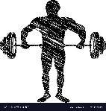 | Find 3 things that produce light and 3 things that produce sound in your house. Draw and label a picture of each.  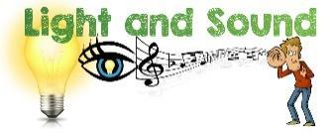
Make a musical instrument using things from home.  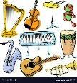 | Look in the mirror and draw what you see. Don’t forget what is around you.  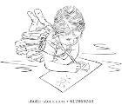 | Cook something with an adult. | Clean your room.  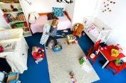 | Learn to tie your shoelaces. Relace them and tie them differently.  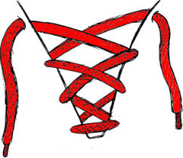

Free Choice activities: (online)
Alphablocks (Phonics)  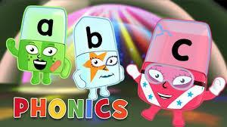  https://www.youtube.com/watch?v=s7LjGDcXqcs | Vooks (Story Telling)  https://www.youtube.com/channel/UCGfA6UdZEmpIwBZ4btAKkgA | Storyline online (Story Telling)  https://www.storylineonline.net/
Drawing with Mo Willems  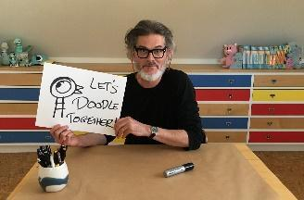  https://www.washingtonian.com/2020/03/16/mo-willems-is-hosting-a-livestream-doodle-starting-today/ | Cosmic kids Meditation  https://www.cosmickids.com/mindfulness-meditation-videos-kids/ | Cosmic kids Yoga  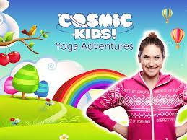  https://www.youtube.com/watch?v=K7FUbTac_ds
Art for Kids (Directed drawing)  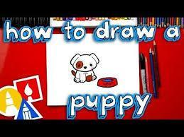  https://www.youtube.com/user/ArtforKidsHub | Just dance  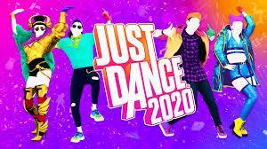  https://www.youtube.com/watch?v=ziLHZeKbMUo | Jack Hartmann  https://www.youtube.com/channel/UCVcQH8A634mauPrGbWs7QlQ

