Stage 1
Learning at Home
Reading
Read for 20 minutes each day (or more if you can!).
Spelling
Week 9  SOUND: sh  SIGHT WORDS: Choose 5 words off the NZCER Essential Word list  or learn:  they, and, can, play | Week 9  SOUND: sh  SIGHT WORDS: Choose 5 words off the NZCER Essential Word list  or learn:  are, for, you, like | Week 10  SOUND: ng  SIGHT WORDS: Choose 5 words off the NZCER Essential Word list  or learn:  come, see, said, here | Week 10  SOUND: ng  SIGHT WORDS: Choose 5 words off the NZCER Essential Word list  or learn:  in, this, am, we

Choose at least one activity to do each day with your sight words and words with your focus sound e.g. if your focus sound is ‘sh’ you could use words like ship, sheep, fish, wish, shampoo.
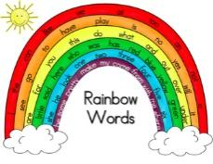  Write your words in rainbow colours | 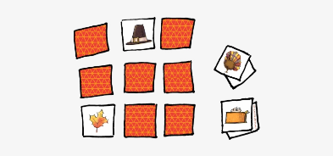  Make word cards. Play SNAP, GO FISH or MEMORY. | Write a poem or song with your sight words or words with the focus sound. | Spell your words out loud while bouncing a ball or jumping on the trampoline.  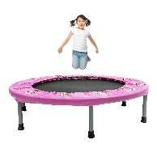 | Write your words with a paintbrush and water.  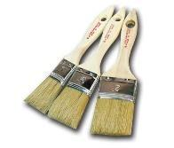
Draw a picture and hide your words in it.  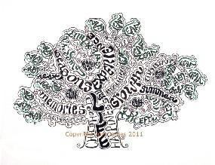 | With a scrap piece of paper make a paper chain and write your words on it.  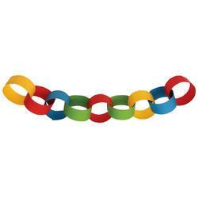 | Use newspapers or magazines to cut out your words. | Jumble your words and see if a family member can unjumble them!  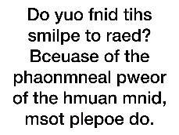 | Build your spelling words using any materials you can find around the house – playdough, sticks, rocks, buttons, LEGO etc.  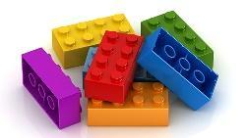

Writing
Complete a writing task each day.
Write a letter to a family member.  This Photo by Unknown Author is licensed under CC BY-SA | Keep a daily journal. | Walk the dog, catch, skip, kick a ball, trampoline, dance etc. Write a story and draw a picture of how you were active this week.  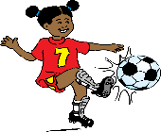 | Go outside and listen to the noises around you. Write down what you can hear. Choose one or more and write about how it makes you feel. | Imagine you are invisible for a day – write about where you would go, what would you do.
“I was on safari and a giant tiger…” Finish the story!  This Photo by Unknown Author is licensed under CC BY-SA | “Suddenly, in a puff of smoke a dragon appeared…” Finish the story!  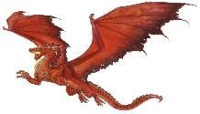 | If one of your toys could talk, what would it say?  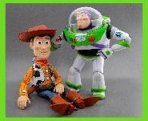 | The postman comes to the door and delivers you a HUGE parcel. Write about what it is. | Cook something in the kitchen with an adult. Write down the recipe.  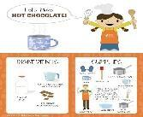
If you could ask your teacher 5 questions, what would they be? | List all of the things that you can do to help family and friends. | Write a letter to a superhero. | Write a letter to a friend and tell them why we need to save water. | Create a ‘WANTED’ poster for Mr Price. Include a description of him and a reward. What was his crime?
Choose an animal that you love. Write everything you know about it. | Create an advertisement for any food or drink product that you like. | Write about what you think makes a really good friend. | Invent a monster and describe it. Describe the features and where it lives. | Should junk food be sold at school? Write about why you think it should or should not.

Maths
Use the number cards provided or some playing cards and choose some games to play from this list:
Play snap with your cards. Snap when the cards add up to a chosen number between 2 and 9 e.g. 8 (4 and 4, 6 and 2 etc.) | Create a number/symbol pattern and get someone in your family to continue it. | Play memory or go fish with your number cards. | Choose two cards and add them together. Repeat this activity 10 times. Record your answers. | Choose a card and take that number away from 30. Repeat this activity 10 times. Record your answers.
Order your cards in ascending order (lowest to highest) and then order them in descending order (highest to lowest).  Can you race a family member and beat them? | Use informal units to measure the length of objects in your house. | Choose a card and record its friend of 10 and friend of 20. Repeat this activity 10 times.  Can you race a family member and beat them? | Turn over 4 cards (1-9 only) to make 2 2-digit numbers. Start at the first 2-digit number and jump by tens then ones to find the total. | Pick two cards and tell your family – the total of my cards is “__”. The family member needs to work out what your cards are. Show them 1 card if they get stuck.

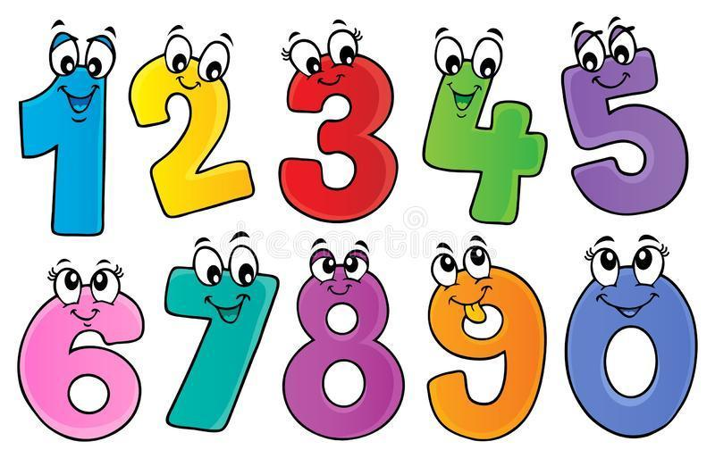
Think about these questions and record your answer. Try to do a few each week.
The answer is 5, can you think of more than one question?
I’ve got 6 coins in my piggy bank. Write 5 different amounts that I can have.
Write ten things that could take one minute to do.
Let’s talk about feet. If a snail has 1 foot, a crab has 10 feet, dogs have 4 feet, people have 2 feet, spiders have 8 and
insects have 6. In your backyard there are snails, crabs, dogs, spiders, people and insects. If there are 23 legs, what
animals can you see?
Record all the different ways you can make the number 20.
Create your own map. Write down directions to get to a special location.
Do you have a ruler in your house? Measure as many different items in your house that you can. How many can you draw and write the measurement for?

Free Choice
Choose one activity (or more!) to do each day
Play a board game with someone at home.  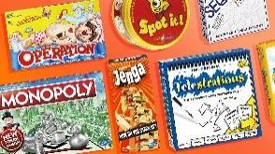 | Take the dog for a walk. | Help out in the kitchen, wash up, vacuum the floors.  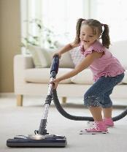 | Make an indoor / outdoor cubby house.  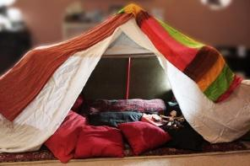 | Plan a picnic in your backyard with your family. Think about what you need to pack- food, drink, games etc.  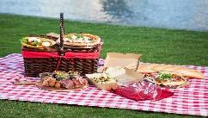
Find some recyclable materials and make them into something new.  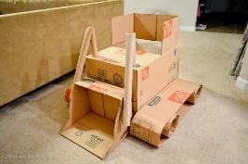 | Graph the weather each day – did it rain? – was it cloudy?  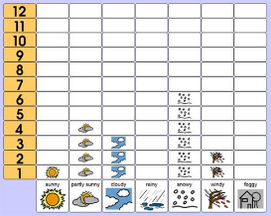 | Walk around your house and backyard looking for natural and built features. Record your findings by drawing pictures of what you find.  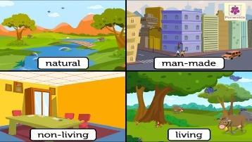 | Count aloud by 2’s, 5’s and 10’s whilst skipping with a skipping rope (one jump for each number) . You could also do this jumping on the trampoline or bouncing a ball.  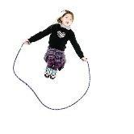 | Draw a floor plan of your house and label it – you can also include some comments about each room if you like.  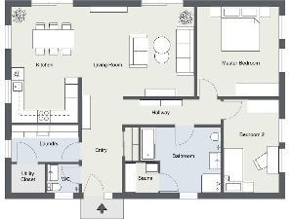
Create a 3D artwork of a chosen bug or insect.  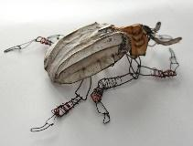 | Call a family member or friend on the phone and talk about your day. | Make up a dance to your favourite song. | Make a list of 5 items that are heavier than you and 5 items that are lighter than you.  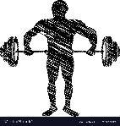 | Find 3 things that produce light and 3 things that produce sound in your house. Draw and label a picture of each.  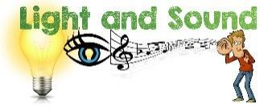
Make a musical instrument using things from home.  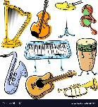 | Look in the mirror and draw what you see. Don’t forget what is around you.  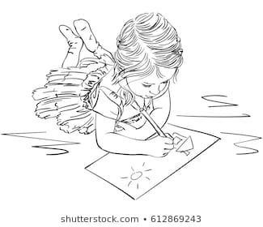 | Cook something with an adult. | Clean your room.  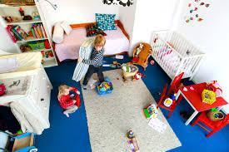 | Learn to tie your shoelaces. Relace them and tie them differently.

Free Choice activities: (online)
Mystery Doug  https://mysterydoug.com/  0:56 | Bill Nye the science guy  https://www.youtube.com/watch?v=nDN7M0J3HXc | Alphablocks  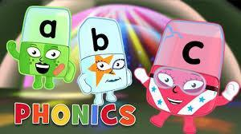  https://www.youtube.com/watch?v=s7LjGDcXqcs
Drawing with Mo Willems  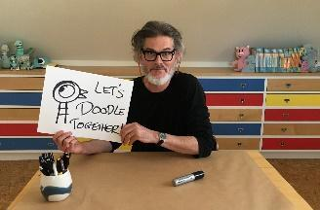  https://www.washingtonian.com/2020/03/16/mo-willems-is-hosting-a-livestream-doodle-starting-today/ | Cosmic kids Meditation  https://www.cosmickids.com/mindfulness-meditation-videos-kids/ | Vooks  https://www.youtube.com/channel/UCGfA6UdZEmpIwBZ4btAKkgA
Cosmic kids Yoga  https://www.youtube.com/watch?v=K7FUbTac_ds | Just dance  https://www.youtube.com/watch?v=ziLHZeKbMUo | Wonderopolis  http://wonderopolis.org/
Storyline online  https://www.storylineonline.net/ | Art for Kids (Directed drawing)  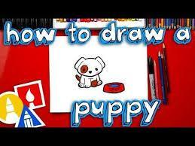  https://www.youtube.com/user/ArtforKidsHub | Math Seeds  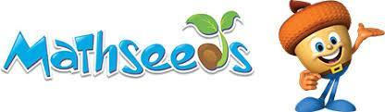  https://mathseeds.com.au/
Number jacks  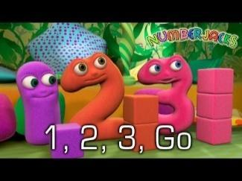  https://www.youtube.com/watch?v=HWssJJuk_Bk | Wordle  http://www.wordle.net/
Spelling city  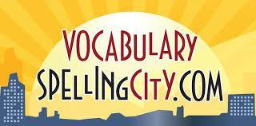  https://www.spellingcity.com/ | Tynker  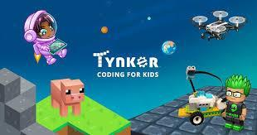  https://www.tynker.com/ | Moe Jones Fitness  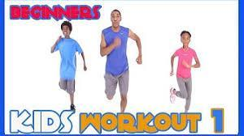  https://www.youtube.com/results?search_query=moe+jones+kids+fitness
Ict Games (English and Maths)  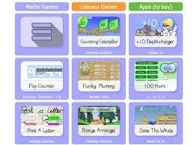  https://www.ictgames.com/ | ABC splash  https://education.abc.net.au/home-old | Scratch (coding)  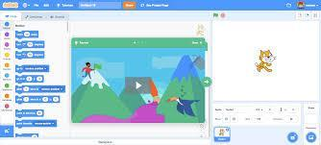  https://scratch.mit.edu/

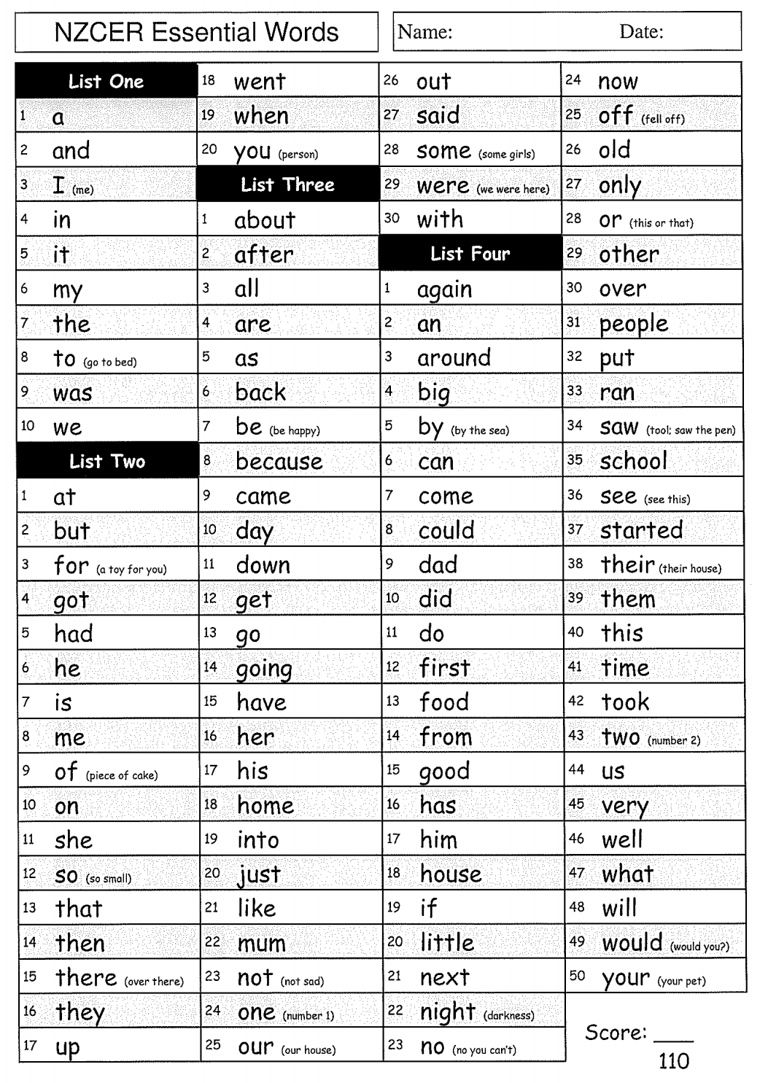

1 | 2 | 3 | 4 | 5
6 | 7 | 8 | 9 | 10
11 | 12 | 13 | 14 | 15
16 | 17 | 18 | 19 | 20

