STAGE 2
LEARNING AT HOME
Word list- Access your spelling list on google classroom.
Spelling - Choose at least one activity to do each day with your words.
Write sentences using your spelling words. Correctly punctuate and use a variety of sentence structures. | Use newspapers and magazines to locate letters and create your spelling words! | Write your words and draw a picture to match it. | Circle the vowels with one colour, and all the consonants with another colour. | Spell your words…backwards! Can you say each word?  knird
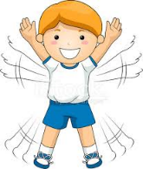  Do star jumps as you spell each word! | Write you words in pyramid writing.  c  e.g. c a  c a t | Create word boxes to represent each letter in your spelling words.  e.g. | Using any kind of decorative letter style eg bubble writing, rainbow writing and write your spelling words. | Go on the computer. Use your words and create a wordle.  http://www.wordle.net/
Write your spelling words with the hand you do not normally use. Is it neat or untidy? | Look at your words. Find a way to sort them into 3 different groups. Make sure every word fits in a group. | Create a find a word using your spelling list. | Write your words in alphabetical order. | Look up the AUSLAN alphabet online then spell you words using sign language.

Reading - Read for 20 – 30 minutes a day (or more if you can!)
Read the text aloud to someone in your family. | Retell your story to a family member. | List 5 most important events/facts from the text. | Construct a time line for the events in the book. | After reading…  Design a new cover for your book. Make it visually appealing and related to the text.
Before reading an imaginative text…  Predict what you think might happen in the story. Write your prediction down and check if you were right after reading the book. | Before reading an informative text…  What do I know?  What do I want to know?  After reading…  What did I learn? | After reading write a book review  List the best parts, worst parts, who it is most appropriate for and an overall rating. | Vocabulary  Write down any tricky words from your book along with the page number. Look up the meanings of the words and then write a new sentence using each of your tricky words. | Visualising  After you read an imaginative text, draw a picture of your interpretation of the characters. Colour and label.

Writing - Complete a writing task each day.
Write a letter to a family member. | Create an advertisement for  any food, drink or product you like. Make sure you persuade the reader to want to purchase the item. | Login to Pobble 365. Pick a picture. Complete the writing task that is attached to the picture you choose. | Write an acrostic poem using your first and last name. | Keep a journal of your daily activities and feelings.  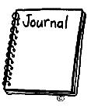
Write an informative text  about your favourite animal. Include their classification, diet, habitat and any interesting facts. | Write a description on what you can see from out of your door or window at your home. Use your senses, adjectives and correct punctuation. Draw a picture to match your writing. | Create a ‘Wanted’ poster for someone in your family. Include a description of them and a reward. What was their crime? | Imagine you are a super hero. What is your super power? Write a description of your self and how you can help the world. | ___________ is the best sport ever. Write a persuasive text to encourage other kids to join the sport with you.
Write a letter to a character from a text you are reading. Let them know what you like about their character, what you would like their character to do in the text. | Watch a BTN story and summarise the story. | 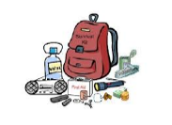  Make a list of 10 survival items you would need if you were deserted on an island. | Design a postcard using your home as a holiday destination. Write on the postcard as if you are going to send it to your teacher. | Explain the rules of handball or another game. Make sure you include ALL of the important ways to play the game fairly.
Create a comic strip about a text you have read. | Write a description of any character in the book. Describe what he/she looked like, but also include other details that you can infer- such as favourite colour, horoscope sign, sports liked, and even a bumper-sticker or a T-shirt. Explain your choices. | Choose a character from a text and write a diary entry from their perspective. How are they feeling about the events that have taken place in your text? Remember it should be written in past tense and use the word ‘I’ as you are pretending to be a character.  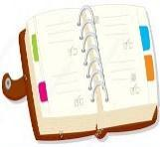 | Write a poem based on a character from a text. Use descriptive words to help responders visualise what your character is like. You may also choose to write a rap about a character. | Acrostic Poem  Write an acrostic poem using the word ‘AMAZING’

Mathematics - Complete at least one Maths task each day.
I have six coins in my piggy bank. How much money could I have? List 5 different amounts I could have. | Login to Mathletics and complete set tasks. | 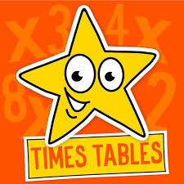  Learn your times tables. | Pick 5 four-digit numbers.  Put these numbers in ascending order and represent them using words, objects and numerals. | Create 10 number patterns. Put a error in each one and get a family member to correct it.
The answer is 25. List as many questions as you can with that answer.  CHALLENGE: Can you get 50?? | 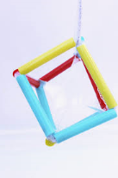  Be creative and construct as many 3D shapes as possible using any material. | Create a survey on any topic, make it into a table and then graph your results.  Use Microsoft Excel if you have computer access. | Choose 10 numbers and write them in expanded notation.  Eg  6573  6000 + 500 + 70 + 3 | Find 2D and 3D everyday objects in your house. Make a list, use tally marks and then create a table and graph.
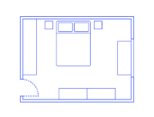  Draw a floor plan of your bedroom. | Using metre long steps, find the perimeter and area of your backyard.  Display as a diagram. | Create a treasure island or theme park map. Give your map to someone in your family and give them directions to follow on the map. | Predict and measure the capacity (amount of liquid) of containers in your household. Try the bathroom sink, a saucepan. | What are all of the factors of:  10, 12,16,20,24,30,36,48, 50

Free Choice - Choose at least one free choice activity a day.
Design a healthy menu for a day at home. | Imagine if 2 animals combined to make a new animal. What would it be? | Peel the vegetables for dinner. Set the table. Help with the cooking and cleaning up. | Create a PowerPoint on your own choice of topics. | 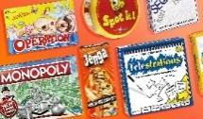  Play a board game or card game.
Make up a dance to your favourite song. | Take the dog for a walk. Don’t have a dog?? Walk your family. | Choose 2 items in your house. What are the similarities and differences? | Make an indoor/outdoor cubby house. | Cook a snack (cookies, cupcakes, pikelets).
You get home from school and all the furniture is stuck on the roof. Explain how that happened!! | 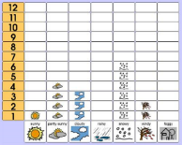  Graph the weather each day – did it rain? – was it cloudy? | Cloud painting. Look up at the clouds for 5 minutes. What can you see. Make it into a description or a picture. | Count aloud by 2’s, 5’s and 10’s whilst skipping with a skipping rope (one jump for each number). You could also do this jumping on the trampoline or bouncing a ball. | 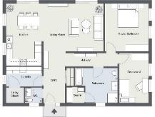  Draw floor plan of your house.
Draw 3 squiggles on your page. Be creative and make it into a REAL picture. | List 10 alternate uses for a paper clip. Do the same activity with other items of your choice. | What are the good and bad things about….  A pencil, iPad, scooter, chair or object of your choice. | How would the world be different if there was no:  Music, lollies, cars, McDonalds, toilet paper? | Make your bed and clean your room 7 days in a row.

