STAGE 3
Learning at Home
Spelling – Access your spelling list on google classroom. Choose at least one activity to do each day.
Write sentences using your spelling words. Correctly punctuate and use a variety of sentence structures. | Use newspapers and magazines to locate letters and create your spelling words! | Write words in alphabetical order. | Circle the vowels with one colour, and all the consonants with another colour. | Spell your words…backwards! Can you say each word?  hctac
Create a word search with your spelling words.  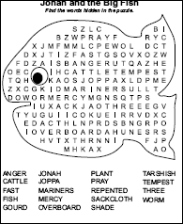 | Write you words in pyramid writing.  c  e.g. c a  c a t | Write 3 synonyms and antonyms for each of your spelling words. | Using any kind of decorative letter style (ie bubble writing, rainbow writing) and write your spelling words. | Go on the computer. Use your words and create a wordle.  http://www.wordle.net/
Write your spelling words with the hand you do not normally use. Is it neat or untidy? | Look at your words. Find a way to sort them into 3 different groups. Make sure every word fits in a group. | Play spelling dollars to work out the value of your words.  Vowels = $1  2 Syllables = $2  3+ Syllables = $3 | Play noughts and crosses or hangman with your spelling words. | Look up the AUSLAN alphabet online then spell you words using sign language.
Reading - Read for 30 – 40 minutes a day (or more if you can!)
Read the text aloud to someone in your family. | Retell your story to a family member. | List 5 most important events/facts from the text. | Construct a time line for the events in the book. | After reading…  Design a new cover for your book. Make it visually appealing and related to the text.
Before reading an imaginative text…  Predict what you think might happen in the story. Write your prediction down and check if you were right after reading the book. | Before reading an informative text…  What do I know?  What do I want to know?  After reading…  What did I learn? | After reading write a book review  List the best parts, worst parts, who it is most appropriate for and an overall rating. | Vocabulary  Write down any tricky words from your book along with the page number. Look up the meanings of the words and then write a new sentence using each of your tricky words. | I Wonder  Create 5 I Wonder questions after reading an imaginative texts
Writing - Complete a writing task each day.
Write a letter to a family member. | Keep a journal. Record all your daily activities and feelings. | Login to Pobble 365. Pick a picture. Complete the writing task that is attached to the picture you choose. | Look at old family photos. Write a recount about what happened that day. | Write an informative text  about one of the planets.
___________ is the best sport ever. Write a persuasive text to encourage other kids to join the sport with you. | Watch BTN and summaries your favourite story. | Design a postcard for your favourite holiday destination. Write on the postcard as if you are going to send it to a friend. | Write a recipe for your favourite food. Illustrate each step. | Design a new cover for your book. Make it visually appealing and related to the text.
Design or draw a suitcase or schoolbag (whichever is appropriate) for a character from a text. Include items that would be important to them and show the kinds of things they like. You could include clothing, toys, food, keepsakes, awards, photos, books- anything at all that you think your character would own. | ___________ is/is not the best subject at school. Convince an audience. | 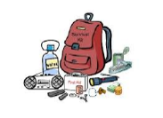  Make a list of 10 survival items you would need if you were deserted on an island. | Create a comic strip that relates to a text you have read. | Explain the rules of handball or another game. Make sure you include ALL of the important ways to play the game fairly.
Acrostic Poem  Write an acrostic poem using the word ‘HOUSE’ | Invent word games from a text you have read. Create crossword puzzles, word games, and acrostics using unfamiliar vocabulary words, characters, and settings.  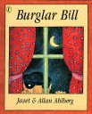 | Drawing  Draw your favourite picture from an imaginative text you are currently reading. Label your drawing | Narrative  Write an imagnative text titled ‘The Day I Travelled to Space.’ | Design and illustrate a travel brochure designed to advertise the "world" of your novel. Remember that a travel brochure should include important places to see and things to do, as well as detailing accommodation and how people can travel around. It should be descriptive and persuasive.

Mathematics - Complete at least one Maths task each day.
Add three or more numbers with different digits without the use of technology. Complete 10 problems.  Eg  5 + 23 + 456 = 484 | Login to Mathletics and complete set tasks. | Create a fraction wall using paper.  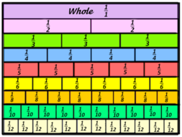 | Revise times tables. Time yourself and try and beat your personal best!  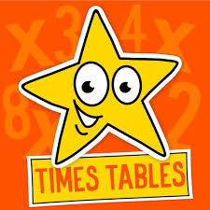 | Find 10 angles in the house that are right angles.  EXTENSION: - find reflex angles.
Estimate, measure and compare the volume and capacity of containers at home. | 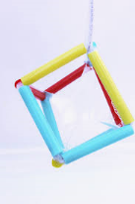  Be creative and construct as many 3D shapes as possible using any material. | Create a survey on any topic, make it into a table and then graph your results.  Use Microsoft Excel if you have computer access. | Create 10 increasing number patterns and 10 decreasing number patterns. | Find 2D and 3D everyday objects in your house. Make a list, use tally marks and then create a table and graph.
Draw an analogue clock. Insert the times for 8:45, 9:30, 12:00, 3:15, 6:25, 7:40, 10:05 | Using a protractor, create 5 acute angles and 5 obtuse angles. | Create a treasure island or theme park map. Include a compass rose, key and other main feature. | Estimate the perimeter and area of your room. Find a way to then measure the perimeter and area. | What are all of the factors of:  10, 12,16,20,24,30,36,48, 50

Free Choice - Choose at least one free choice activity a day.
Design a healthy meal plan. | Imagine if 2 animals combined to make a new animal. What would it be? | Peel the vegetables for dinner. Set the table. Help with the cooking and cleaning up. | Create a PowerPoint on your own choice of topics. | 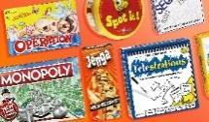  Play a board game or card game.
Make up a dance to your favourite song. | Take the dog for a walk. Don’t have a dog? Walk your family. | Choose 2 items in your house. What are the similarities and differences? | Make an indoor/outdoor cubby house. | Cook a snack (cookies, cupcakes, pikelets).
You get home from school and all the furniture is stuck on the roof. Explain how that happened!! | 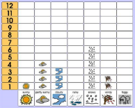  Graph the weather each day – did it rain? – was it cloudy? | Cloud painting. Look up at the clouds for 5 minutes. What can you see. Make it into a description or a picture. | Count aloud by 2’s, 5’s and 10’s whilst skipping with a skipping rope (one jump for each number). You could also do this jumping on the trampoline or bouncing a ball. | 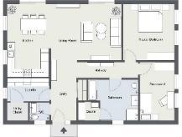  Draw floor plan of your house.
Draw 3 squiggles on your page. Be creative and make it into a REAL picture. | List 10 alternate uses for a paper clip. Do the same activity with other items o your choice. | What are the good and bad things about….  A pencil, iPad, scooter, chair or object of your choice. | How would the world be different if there was no:  Music, lollies, cars, McDonalds, toilet paper? | Make your bed and clean your room 7 days in a row.

